**Dawlance 1041 SR Water Dispenser**

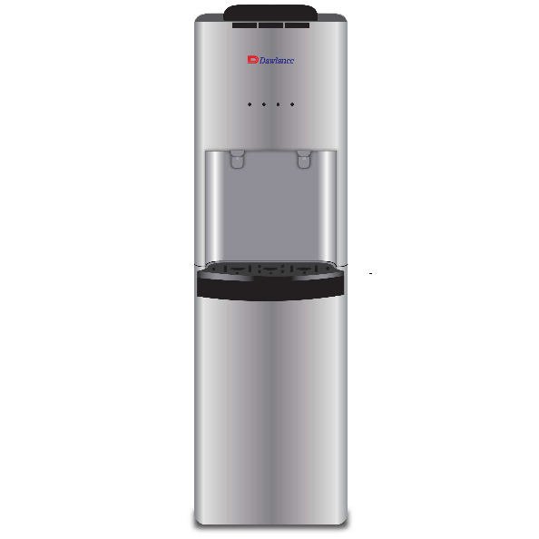

|  |  |
| --- | --- |
| **Type:** | Floor Standing |
| **Water Supply(l):** | 17 |
| **Weight(kg):** | 28 |
| **Unit Dimensions(H*W*L)mm:** | 340 x 434 x 1155 |
| **Power Supply:** | 225W |
| **Filter Stages:** | 2 |